Kaitaia Publishing Collective

Haris Khan, Konan Kouame, Ryan Horwitz, Christopher Luzzi, Benjamin Jackson

CSC 3710 Methods Systems Analysis - Fitchburg State University

# Information

First page: Introduction - Ryan Horwitz

Second page: System Request - Haris Khan

Third page: Feasibility Analysis - Ben Jackson

Fourth page: Cost-Benefit Analysis - Konan Kouame

Fifth page : Project Recommendations - Christopher Luzzi

**Introduction**

Our company is Software Unlimited, we are specialists in providing business solutions for small and medium sized businesses. We are a firm that has built a reputation for not automatically promoting ‘the computer’ as an answer to our problems. Kaitaia Publishing Collective contacted us in regards to helping them with errors and anomalies that they are facing during their publishing process. They are only looking to add computerization upgrades where it is deemed necessary and cost-effective. Kaitaia Publishing wants to improve their Manuscripting process to better it’s public profile and publicity. Their improvements are focused on attracting more established authors by gaining a reputation for fast efficient publishing and good-deal contracts. Enhancing the publishing collective system is very important to the company, the process includes a plethora of steps and considering that a recent error in the process caused an author to withdraw from any future dealings has made it a principal factor to improve. The collective would like to have a better way of understanding their sales, marketing and distribution, there is trouble occurring with knowing if there are still copies left in stock and having to contact retail outlets to be able to locate the spare copies. They believe they are losing out on many different opportunities in regards to re-orders and their expected sale volumes for particular outlets. This is caused by them not following up on all requests and subsequently missing out on something that would highly benefit them. Organizing the payments to authors is the company's final issue that needs to be polished up. They have had situations where checks have been given to authors where sales have been negative and thus they are losing money. We are going to implement ways to help Kaitaia Publishing improve their way of dealing with different types of scenarios so that the company runs much more smoothly and effectively.

**System Request**

Purpose -A new system would prove useful within the Kaitaia Publishing Collective. It would prove beneficial to the company because it would reduce or prevent errors from occurring which could potentially save the company thousands. Due to human error and lack of record keeping, Kaitaia has lost thousands of dollars over the years. Implementing a new system would prove beneficial to the company not just upon implementation but also throughout the years the system is being used.

Business Need

Kaitaia Publishing Collective faced a major loss last year due to an ISBN mismatch conflict. This error had not been detected until after printing and the need for reprinting arose which prompted for a thorough systems analysis to be done. A system would assist with detecting these errors beforehand, and could potentially save the company the time and resources needed to resolve this.

Annual Benefits

Implementing a new system will benefit Kaitaia Publishing Collective in the long run. Throughout a four year period the company should expect to see an increase in productivity and sales with this new system in place. This system will allow them to keep records and documentation of inventory. Record keeping will prevent errors from occurring and costly mistakes will become less and less overtime and save the company money and resources.

Summary

We believe that a new system will prove beneficial to the company. It will save the company money and resources in the long run and this is extremely crucial in obtaining a better company image and keeping customers satisfied.

**Feasibility Analysis**

Organizational

This new system would be very beneficial on an organizational level. As it stands, documents vital to the publishing process regularly go missing, and this has affected the Collective’s ability to respond to requests for reprints, and has negatively impacted their reputation with existing and potential clients.

As long as the members of Kaitaia Publishing Collective are trained and willing to use the new system, we believe that it will result in a more organized and efficient work environment. Using this system will help to improve Kaitaia Publishing Collective’s public image, and alleviate the worries potential clients currently have towards working with the Collective.

Economical

This new system will be economically feasible, and while it may not see a return-on-investment until approximately the midway point of the third year, it will indeed turn a profit for the Collective. The initial costs were kept low, while still aligning with the Collective’s wishes.

Technical

This new system will be technically feasible. It is an easy-to-understand system that won’t require much training for the Collective’s employees to understand, and won’t require much maintenance to upkeep. Kaitaia Publishing Collective doesn’t want to just resort to the computer to solve all of their issues, and we kept that in mind when designing this system. For example, instead of using a full computer-terminal system, we incorporated typewriters, which will alleviate the issues that come from other network systems.

**Cost-Benefit Analysis**

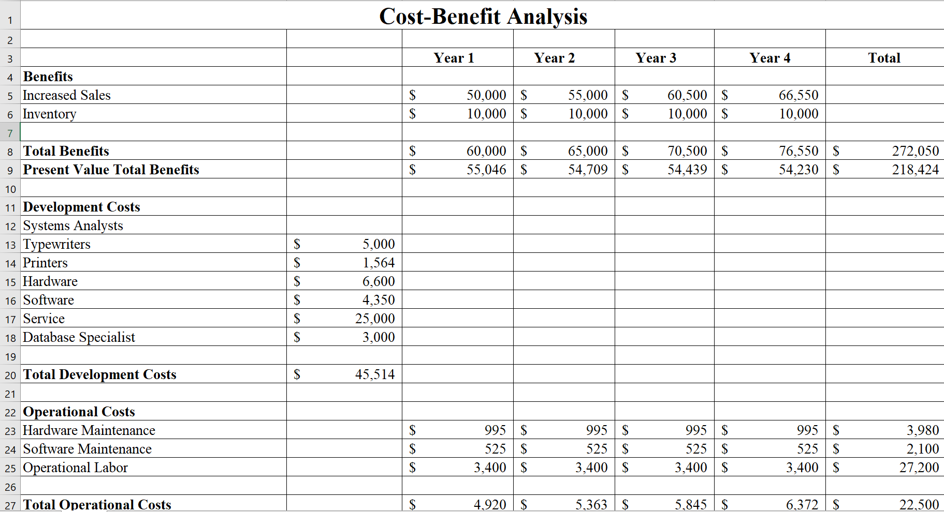

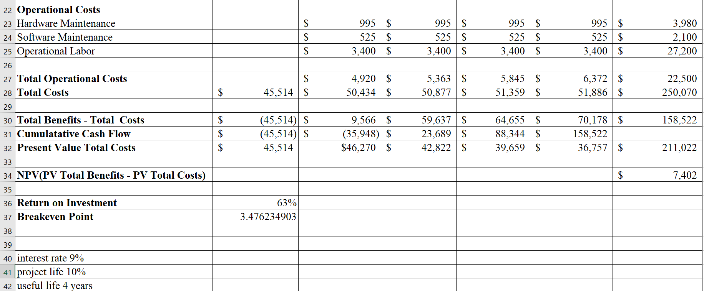

ROI = $250,070/ $158, 522

ROI = 63%

Break-even point = 3 + (70,178- 36,757)/ 70,178

Break-even point = 3.47 years

**Project Recommendation**

From what our company has to offer and the needs of Kaitaia Publishing it would be in the best interest of Kaitaia Publishing to move forward with computerization upgrades. The upgrades can help reduce the amount of errors and anomalies that they are facing during their publishing process. These improvements will also increase the amount of new authors because the upgrades will make publishing faster and better contract deals. Kaitaia will be able to keep better track of sales, marketing, distribution, and inventory of manuscripts. Furthermore, our calculations from our cross benefit analysis shows that the company’s ROI will increase 63% and break even point will be around 3 years and 5 months respectively. Our recommendation is to move forward with the project.